CS008

Zach Bernstein, Olivia Hurd, and Maria Kissel

Assignment: Final Project- Bernstein & Co.

Final Project: Bernstein & Co.

Version <1.0>

Table Of Contents

Time Log 3

Introduction 4

Purpose 4

Definitions, acronyms, and abbreviations 4

Overall Description 4

Story Board 5

Specific requirements 6

|  |  |  |  |
| --- | --- | --- | --- |
| Time Log | | | |
| Estimated time to complete assignment => | | | 40 Hours |
| Date | Time Spent  (in hours) | Description | Author |
| 3/29 | .75 | First Version of Software Requirements | Zach, Olivia, Maria |
| 3/30 | .75 | Body content for homepage + images | Maria |
| 4/03 | 2 | Body content for About page + images | Olivia |
| 4/05 | .75 | Group meeting about progress + new task assignments | Zach, Olivia, Maria |
| 4/05 | .75 | Top.php completed | Zach |
| 4/09 | 1.5 | Menu & owner page content | Olivia |
| 4/12 | 1 | Menu & owner page content | Maria |
| 4/13 | 1 | Group meeting – upload progress + new task assignments | Zach, Olivia, Maria |
| 4/21 | 1 | Top, Nav, and Footer | Zach |
| 4/24 | 1 | Location info for each restaurant | Maria, Olivia |
| 4/27 | .75 | Group meeting + upload finished html code + new task assignments | Zach, Olivia, Maria |
| 4/28 | 2 | PHP reservation code | Zach |
| 4/28 | 2 | CSS development | Maria |
| 4/29 | 1 | PHP reservation code | Zach |
| 4/29 | 1.5 | CSS development | Maria |
| 4/30 | 2 | CSS development | Maria |
| 5/2 | 2 | Group Meeting + HTML reservation code | Zach, Olivia, Maria |
| 5/2 | .75 | CSS development | Maria |
| 5/3 | 1.5 | CSS development | Maria |
| 5/3 | 1 | Spec document updating | Olivia |
| 5/4 | 4 | Final group meeting + finishing touches + syncing files + finishing spec document | Zach, Olivia, Maria |
| 5/4 | 1 | Restructured site directory structure | Zach |
|  | 28 | <=Total Time Spent |  |

# Introduction

### Purpose

The purpose of this document is to describe the requirement specification for the web site “Bernstein & Co”.

The intended audience for this document is anyone who may be

*First it is the contract between you and the client. Second it is for the developer of the site. Two primary goals are:*

1. *Client gets a very good understanding of what you will be delivering.*
2. *Developer has a very good understanding of what they are going to create.*

### Definitions, acronyms, and abbreviations

*Sample for the client:*

ER Diagram – a diagram to represent the data you want to save with your system

W3 Validation – refers to both Html and CSS validation tool provided by the W3c.org. the html validator is located at:

<http://validator.w3.org/>

with the CSS validator located at:

<http://jigsaw.w3.org/css-validator/>

# Overall Description

Our website provides information about a steakhouse we created called Bernstein & Co. We created a back story for this family-run restaurant and developed it as a modern yet classic restaurant serving food made with the highest quality ingredients perfect for celebrating any occasion. Bernstein & Co. has three locations: Boston, MA, Chicago, IL, and Burlington, VT. Each location has a different menu, which can be accessed through our website. A map shows each of the locations, and users can easily find the restaurant’s address, phone number, and hours of operation. Visitors to our website can also make reservations quickly and easily by providing some simple information to help us prepare them for the best experience possible. We ask for the number of people in the party, the restaurant location, the preferred date and time of the reservation, and contact information, as well as additional information to let us know if the group will need any kids’ menus or high chairs.

# Story Board

**Sitemap of Bernstein & Co.**



**CSS/Storyboard**



# Specific requirements

1. *Title for main page*: Bernstein & Co.
2. *Meta Description*: *Bernstein & Co. Steakhouse*
3. *Meta Character set*: UTF - 8
4. *Logo*: **, 
5. *Main page photo*:

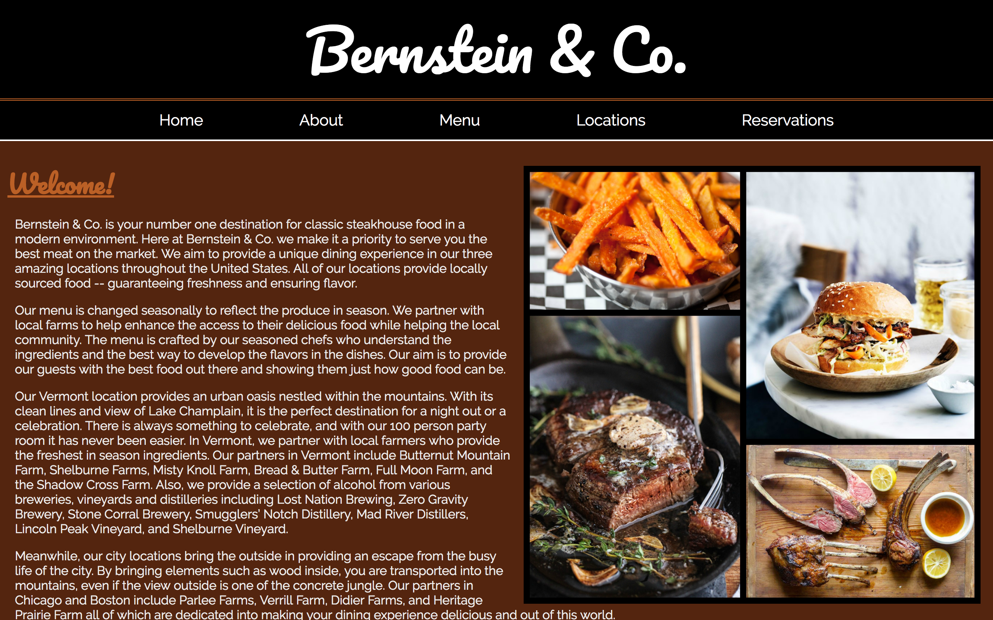

1. *HTML Validation –* All pages will pass W3C Html validation for html 5. NOTE: top, nav and footer pages will not validate as they are not expected to be viewed by themselves.
2. *CSS Validation* – All pages will pass W3C 3.0 CSS validation.
3. *CSS* – All pages will have a linked style sheet.
4. *Navigation* – All pages will contain navigation to all other pages on the site. File name should be nav.php
5. *Content* – The home page, about page, owners pages, and menu pages, will have a minimum of 500 words.
6. *Top* – All pages will contain top.php which includes a header for each page which has a logo for the website.
7. *Footer* – All pages will contain a footer with the content determined by you. Filename will be footer.php
8. *Form –* Visitors to the website will be able to fill out a form to make a reservation at Bernstein & Co.
9. *Form* – Will contain fieldsets, legends, input type text for email address and a reserve button.
10. *Form* – Will have generic text placeholders in textboxes.
11. *Form* – Process the form’s submission:
    1. Perform security check making sure the page comes from itself.
    2. Flag for each error and style the object with the error on it.
    3. If form is incorrect redisplay form with descriptive error messages displayed before the form.
    4. Sanitize all data.
    5. Check for valid data for being entered
    6. Check email for correct format.
    7. Check that time contains letters, numbers, dash, period, space and single quote only.
    8. Check that phone number of a valid USA phone number.
    9. Save the functions in the lib folder (validation-­‐‑functions.php)
    10. On successful submission display message (don’t display form again).
12. *Form -­‐‑* should email the person who filled it out.
13. *Content –* Reservation details are sent to the email address given.
14. *Form* – add the following inputs to your form (minimum, you can add more):
    1. 6 text boxes: Date & Time, Party Size, First Name, Last Name, Email, Phone Number
    2. 1 list box: Location
    3. Check boxes: Age Groups (3 options)
    4. Radio buttons: Special Occasion (4 options)
    5. Field sets and legends as needed.
15. *Form* – all data should be saved to a csv file.
16. *Form* – Should be styled with CSS.
17. *Footer* – All pages will contain a footer with the content determined by you. Filename will be footer.php
18. *Images* – Home, about, menu, and location pages will have a minimum of one image. Each image will be in the figure element with the figcaption element if needed. The form page does not need to meet this requirement.
19. *File Names* – The form page shall be called reservations.php. All other files should have names indicative of their content if a specific one has not already been mentioned.
20. *Specification Document(this file)*: must be updated and saved as a specs.pdf.